**Chapter 4**

**Applications of Derivatives**

**4.10 Antiderivatives**

**Section Exercises**

**For the following exercises, show that are antiderivatives of.**

465. 

Answer: 

467. 

Answer: 

469. 

Answer: 

**For the following exercises, find the antiderivative of the function.**

471. 

Answer: 

473. 

Answer: 

**For the following exercises, find the antiderivative of each function**

475. 

Answer: 

477. 

Answer: 

479. 

Answer: 

481. 

Answer: 

483. 

Answer: 

485. 

Answer: 

487. 

Answer: 

489. 

Answer: 

**For the following exercises, evaluate the integral.**

491. 

Answer: 

493. 

Answer: 

495. 

Answer: 

497. 

Answer: 

**For the following exercises, solve the initial value problem.**

499. 

Answer: 

501. 

Answer: 

503. 

Answer: 

**For the following exercises, find two possible functionsgiven the second- or third-order derivatives.**

505. 

Answer: Answers may vary; one possible answer is

507. 

Answer: Answers may vary; one possible answer is

509. A car is being driven at a rate of  mph when the brakes are applied. The car decelerates at a constant rate of  ft/sec. How long before the car stops?

Answer: sec

511. You are merging onto the freeway, accelerating at a constant rate of  ft/sec. How long does it take you to reach merging speed at  mph?

Answer: sec

513. A car company wants to ensure its newest model can stop in sec when traveling at  mph. If we assume constant deceleration, find the value of deceleration that accomplishes this.

Answer:  ft/sec

**For the following exercises, find the antiderivative of the function, assuming **

515. [**T]** 

Answer: 

517. [**T]** 

Answer: 

519. [**T]** 

Answer: 

**For the following exercises, determine whether the statement is true or false. Either prove it is true or find a counterexample if it is false.**

521. If is the antiderivative of thenis the antiderivative of

Answer: True

523. If  is the antiderivative of  then is the antiderivative of

Answer: False

**Chapter Review Exercises**

***True or False*? Justify your answer with a proof or a counterexample. Assume that is continuous and differentiable unless stated otherwise.**

525. If and then there exists at least one point such that 

Answer: True, by Mean Value Theorem

527. There is a function such that and  (A graphical “proof” is acceptable for this answer.)

Answer: True

529. Given the graph of  determine whereis increasing or decreasing.

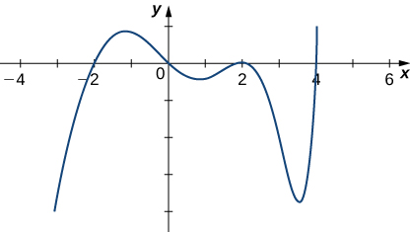

Answer: Increasing: decreasing: 

531. Find the linear approximation to near

Answer: 

**Find the critical points and the local and absolute extrema of the following functions on the given interval.**

533. over 

Answer: Critical point: absolute minimum: absolute maximum:

**Determine over which intervals the following functions are increasing, decreasing, concave up, and concave down.**

535. 

Answer: Increasing: decreasing:  concave up: concave down: 

537. 

Answer: Increasing: decreasing: concave up: concave down: nowhere

**Evaluate the following limits.**

539. 

Answer: 

541. 

Answer: 

**Use Newton’s method to find the first two iterations, given the starting point**.

543. 

Answer: 

**Find the antiderivatives of the following functions.**

545. 

Answer: 

**Graph the following functions by hand. Make sure to label the inflection points, critical points, zeros, and asymptotes.**

547. 

Answer:

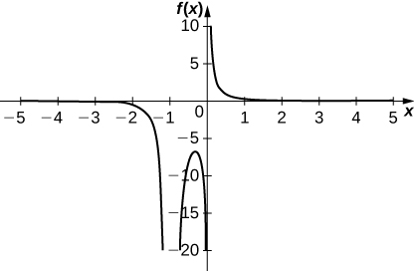

Inflection points: none; critical points: zeros: none; vertical asymptotes: horizontal asymptote: 

549. A car is being compacted into a rectangular solid. The volume is decreasing at a rate of m3/sec. The length and width of the compactor are square, but the height is not the same length as the length and width. If the length and width walls move toward each other at a rate of m/sec, find the rate at which the height is changing when the length and width are  m and the height is  m.

Answer: The height is decreasing at a rate of m/sec

551. The famous Regiomontanus’ problem for angle maximization was proposed during the th century. A painting hangs on a wall with the bottom of the painting a distance  feet above eye level, and the top feet above eye level. What distance  (in feet) from the wall should the viewer stand to maximize the angle subtended by the painting, 

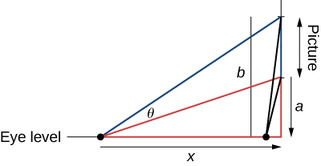

Answer: feet

This file is copyright 2016, Rice University. All Rights Reserved.